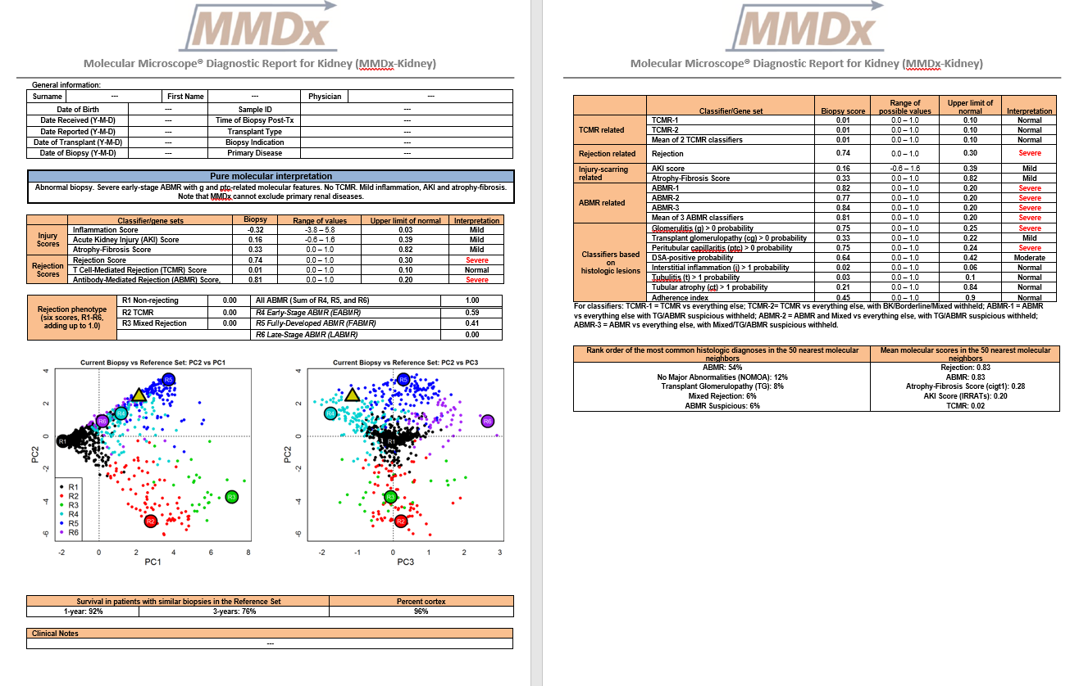
6
7
4
3
9
8
1
2
5
8
9

Our large reference set of 1208 kidney biopsies will be referred to throughout as K1208.
When seeing a new report, we normally look first at the PCA plots to get a quick idea of how the new biopsy looks in relationship to K1208. If it is close to either the R1 (non-rejecting), R2 (TCMR), or R5 (fully-developed ABMR) circles on the PC2 vs PC1 plot, then the diagnosis will probably be straightforward. Uncertainty arises when the new biopsy isn’t close to these archetypal locations, especially when it’s intermediate between R1 and any of the rejecting archetype locations. According to the rules given in our recently submitted paper, the following guidelines would then be used: ABMR if R4+R5+R6>0.60 AND the mean of the three binary ABMR classifiers (page 2 of report) >0.30; TCMR if R2+R3>0.40 AND the mean of the two binary TCMR classifiers >0.20. Mixed rejection if mean binary ABMR classifier >0.30 AND mean binary TCMR classifier >0.20 AND R3>0.30. If those are considered to be guidelines, the following would be “very approximate” guidelines: pABMR = R4+R5+R6>0.30 AND mean binary ABMR classifiers >0.20 AND not ABMR by the ABMR criteria mentioned above; pTCMR if R2+R3>0.20 AND mean binary TCMR classifiers >0.1 AND not TCMR by the TCMR criteria mentioned above. If it is decided that a biopsy has ABMR, a comparison of R4 (early-stage ABMR), R5 (fully-developed ABMR), and R6 (late-stage ABMR)can be used to estimate the stage of the ABMR. Those 3 numbers should be more or less in agreement with some of the lesion classifier scores on page 2: high R4 should have high ptc>0 and g>0 scores relative to cg>0; R5 should have high scores for all 3 of those classifiers; R6 should have high cg>0 relative to ptc>0 and g>0 scores.

Explanation of fields on the MMDx-kidney report (see Example report.pptx):
1 | Patient/clinical information (if available at the time the report is run)
2 | PFH’s sign-out – clinical interpretation of the molecular report
3 | Main (non-archetype) molecular scores for injury and rejection  Column 1 - Classifier/gene sets:  Injury  Global disturbance score = the PC1 score from a principal component analysis of K1208 where the inputs were 9 of our core PBT (pathogenesis-based transcript set) scores, i.e. a 1208 x 9 matrix of scores. The 9 PBTs were: QCATs, GRIT1s, QCMATs, AMATs, ENDATs, IRIT3s, IRIT5s, KT1s and KT2s. Positive numbers indicate inflammation. This score is sometimes unreliable if the % cortex (see below) is very low, due to the large effect this can have on the highly variable KT1 and 2 scores.  Acute kidney injury (AKI) score = the IRRAT PBT score. Higher = more injured.  Atrophy-fibrosis score = a classifier score that estimates the probability of having a ci-lesion score of > 1 (this score is also shown on page 2 of the report). All K1208 biopsies that had a non-missing ci-score were used for training this classifier. As with all our classifiers, the scores reported for biopsies in K1208 are obtained through 10-fold cross-validation. Biopsies collected after this (i.e. those being reported on) have their probabilities calculated based on a single classifier that uses all available K1208 biopsies (meaning, in this case, all K1208s that had a non-missing ci-score).  Rejection  Rejection score = a classifier that estimates the probability of having a histologic diagnosis of either ABMR, TCMR, or Mixed rejection. All 1208 biopsies are used in training this classifier. The binary comparison used for training is ABMR/TCMR/Mixed rejection vs all other biopsies.  T cell-mediated rejection (TCMR) score = a score that estimates the probability of having a histologic diagnosis of TCMR. It is the mean of two classifiers shown on page 2 of the report (TCMR-1 and TCMR-2. See box 8 for their details).  Antibody-mediated rejection (ABMR) score = a score that estimates the probability of having a histologic diagnosis of ABMR. It is the mean of three classifiers shown on page 2 of the report (ABMR-1, ABMR-2, and ABMR-3. See box 8 for their details).  Column 2 – Biopsy score:  The molecular score for the biopsy being evaluated  Column 3 – Range of values:  For the classifier scores, this is just the usual limits imposed on probability distributions – from 0.0 to 1.0. The principal component-based inflammation score and the PBT (AKI/IRRAT) score have no theoretical limits, and are defined here as beint the 2.5 to 97.5 percentiles of the distribution of scores in K1208. I.e. the central 95% of all values.  Column 4 – Upper limit of normal:  For the 3 rejection scores, the upper limits were set based on our experience with the dataset and what we have previously published. These are 0.3, 0.1, and 0.2 for rejection, TCMR, and ABMR respectively. Calculation of the limits for the 3 injury scores is more complicated. First of all, only the K1208 biopsies that were both histologically NOMOA (no major abnormalities and time post-transplant (TxBx) of > 42 days) AND belonged to molecular archetype group 1 (= NR – no rejection) were used. From this subset of K1208, the 50 biopsies closest in time to the biopsy being evaluated are found. Using only these, the score closest to the 90th percentile (where the 0th percentile would be the lowest score) is found – this is the upper limit reported. Therefore, as different biopsies are being tested, the ranges on the reports will change based on their TxBx. Since injury is so strongly related to TxBx, the idea is to find what level of injury would be considered extreme in relatively normal biopsies with similar TxBx.  Column 5 – Interpretation:  This column is again complicated because of different interpretations and categorizations depending on the variable under question. The possible categories for the 3 injury scores are (in order) “Minimal”, “Mild”, “Moderate”, and “Extensive”. For the 3 rejection scores they are “Normal”, “Mild”, “Moderate”, and “Severe”. In all cases the categorical divisions are based on threshholds/cutoffs. These are sometimes “hard-coded” and sometimes dependent on distributions of scores within the data. For the inflammation (=PC1) score, the cutoffs between the 4 categories are set to be {-1, 1,3} i.e. if score < -1, “Minimal”, if -1 <= score < 1, “Mild”, etc. For the AKI and atrophy-fibrosis scores, the 50 biopsies from K1208 that are closest in TxBx to the target biopsy are examined (note that unlike the case for the upper limit calculation, they are NOT required to be in the NOMOA and A1 archetype groups), and the 25th, 50th, and 75th percentiles of the distribution (of AKI or atrophy-fibrosis scores respectively) used. Now for the 3 rejection scores... The lowest threshold for each (i.e. the score below which you must be to get an interpretation of “Normal”) is set to be the same as what was given above for the upper limits of normal: 0.3, 0.1, and 0.2 for rejection, TCMR, and ABMR respectively. From there, you take K1208 and divide the range of scores > the lowest threshhold into tertiles.  - Note also that PFH will occassionally override the automated output and manually change the interpretation.
4 | Archetypal analysis (AA). Archetype analysis is a type of clustering. The user decides a priori how many clusters they want, based on whatever criteria they choose (we chose 6 – see our archetype paper). The algorithm assigns 6 “archetype” centers (the coloured circles R1-R6 in the report diagram. Note that the “R” stands for “rejection” since the inputs for this analysis are all rejection related, therefore this is an AA in “rejection” space. R1-R6 are the same as A1-A6 in our paper). The six archetypes correspond to 1- non rejection, 2- TCMR, 3- a type of mixed rejection that tends to occur early post transplant and may be associated with non-adherence or under-immunosuppression, 4- early-stage ABMR, 5- fully developed ABMR, 6- late-stage ABMR. (Note that besides being mixed rejection because of a high R3 score, it’s possible to be mixed by simultaneously having relatively high R2 and R4/5/6 scores). Every biopsy has scores for R1 through R6, and they sum to 1.0. They can be interpreted as the relative proportion each archetype contributes to the biopsy. To assign a single cluster, the highest archetype score (from R1-6) is used. These are the colours used for the dots on the plots. Note however, that using this “maximum score” convention can be misleading, if a biopsy had R1 = 0.34, R2=0.33, and R4=0.33, it would be coloured black as a R1 (non-rejecting), but clearly the fact that 0.33+0.33=0.66 is the combined “rejecting” archetype score should be taken into consideration.
5 | Principal component analysis (PCA) plots. Used to visually compare the molecular location of the new biopsy being reported (the olive-green triangle) to the other biopsies in K1208. K1208 is used to generate the molecular scores used as input for both the AA, and for visualizing the 6 AA clusters. The input is a 1208 (biopsies) by 7 (molecular scores) matrix of numbers. Each of the seven molecular scores is one of the classifiers shown on the report (although the 1208 x 7 matrix does not of course include the new biopsy’s 7 molecular scores). These 7 scores are those from: ABMR-1, TCMR-1, g>0, cg>0, ptc>0, i>1, t>1. I.e. the 2 rejection types and the main lesions used histologically to diagnose them.  On the left is PC2 vs PC1, on the right is PC2 vs PC3. PC1 represents the molecular continuum going from non-rejection (left) to rejection (right). PC2 represents ABMR (top) to TCMR (bottom). PC3 is ABMR stage, from early (left) to late (right).  Note that the PCA has no direct connection with the AA. PCA plots are just used as a convenient way to show the distribution of scores generated in the AA. That is why you get some overlapping of colours at the boundaries in the plots – there’s not a direct 1:1 correspondence between the dimensionality reduction from the PCA and the clustering in AA.
6 | Miscellaneous: Survival and %cortex.  The survival estimate is based on the empirical distribution of survival in the 50 nearest neighbours (NN) in K1208. (“Nearness” is defined as 3-dimensional Euclidean distance in the PCA space of the figures). Currently this is based on the following calculation, e.g. for 1-year survival in the 50 NN: of the biopsies that either survived to 1 year, or failed within 1 year, what proportion failed within 1 year?  The estimate of the %cortex is based on a logistic regression model that uses the expression of the podocin gene (NPHS2). See our “Effect of Cortex/Medulla” paper.
7 | Clinical notes (if available at the time the report is run)
8 | Similar to the page 1 table, but more scores.  Column 1 - Classifier/gene sets:  TCMR related  TCMR-1 = a score that estimates the probability of having a histologic diagnosis of TCMR. The binary comparison used for training is TCMR vs all other biopsies.  TCMR-2 = like TCMR-1 except that biopsies with borderline rejection, BK virus, or mixed rejection are held out of the training sets. These exclusions are to keep out phenotypes similar to TCMR that might “confuse” the straightfoward TCMR vs everything else analysis of TCMR-1. In reality, TCMR-1 and TCMR-2 are usually quite similar and just represent different opinions on how best to do the analysis.  Rejection related  TCMR/ABMR/Mixed vs all other biopsies.  ABMR related  ABMR-1 = a score that estimates the probability of having a histologic diagnosis of ABMR. The binary comparison used for training is ABMR vs all other biopsies, with TG and ABMR suspicious left out of the training sets.  ABMR-2 = ABMR/Mixed vs all other biopsies with TG and ABMR suspicious left out of the training sets.  ABMR-3 = ABMR vs all other biopsies with TG, ABMR suspicious, and Mixed left out of the training sets.  As with the different TCMR classifier definitions, these can be viewed as different ways of asking the same question – none is the “right” way to do it. This is why we use the mean of the 3 (and the mean of the 2 TCMR classifiers) as our main input on page 1.  Classifiers based on histologic lesions  These are for the most part defined on the report page. E.g. Glomerulitis (g) > 0 is the classifier-based probability of g > 0 obtained by comparing g > 0 biopsies to g=0 biopsies (those with missing g-scores are left out of the training sets).  The DSA positive probability compares biopsies that are DSA+ vs those that are DSA-. Biopsies with no DSA were left out of the training sets. NDSA (PRA+DSA-) were included in the DSA- class for this analysis.  The adherence index is actually an ah > 0 classifier – biopsies with ah > 0 are compared to those with ah = 0.  Column 2 – Biopsy score:  The molecular score for the biopsy being evaluated  Column 3 – Range of possible values:  As on page 1, for the classifier scores, this is just the usual limits imposed on probability distributions – from 0.0 to 1.0. The definition for the only non-classifier (AKI score) can be found in the page 1 details.  Column 4 – Upper limit of normal:  See page 1 details for backgound. The specifics are:  Upper limits for the 2 TCMR classifiers and their mean is set to 0.1.  Upper limits for the 3 ABMR classifiers and their mean is set to 0.2.  Upper limit for the rejection classifier is set to 0.3.  For AKI and atrophy-fibrosis score, see page 1 details.  For the 8 classifiers listed under “Classifiers based on histologic lesions”:  Only the K1208 biopsies that belonged to molecular archetype group 1 (= NR – no rejection) were used. From this subset of K1208, the 50 biopsies closest in time to the biopsy being evaluated are found. Using only these, the score closest to the 90th percentile is found – this is the upper limit reported.  Note that the only difference between these rules and those for AKI and atrophy fibrosis is that for those 2 limits, the subpopulation being used for the ranges had to be not only archetype = 1, but also histologic Dx = NOMOA and TxBx > 42 days.  Column 5 – Interpretation:  The same as the details for page 1 for the injury and rejection scores. For all others (g > 0 and below): take the population in archetype 1=NR. From those, find the 50 biopsies that were closest to the new biopsy’s TxBx. From those, find the 90th percentile – this is the lower limit – anything below this is “Normal”. The range above this point is split into tertiles for the other cutoff points. Note that the categories for these 8 interpretations are like those of the rejection classifiers - “Normal”, “Mild”, “Moderate”, and “Severe” not the “Minimal”, “Mild”, “Moderate”, and “Extensive” we use for ci > 1 and AKI.
9 | Nearest neighbour counts from the molecular nearest neighbours in the PCA plots.  Find the 50 nearest neighbours (3 dimensional Euclidean distance using the PC1-3 scores), and report the frequencies of their 5 most common histologic diagnoses. The mean molecular scores for the atrophy-fibrosis classifier (called cigt1 on the report, = ci > 1), rejection/ABMR1/TCMR1 classifiers, and IRRATs (= AKI score) are also reported.

